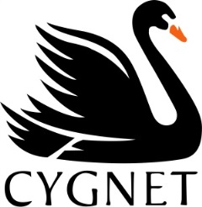
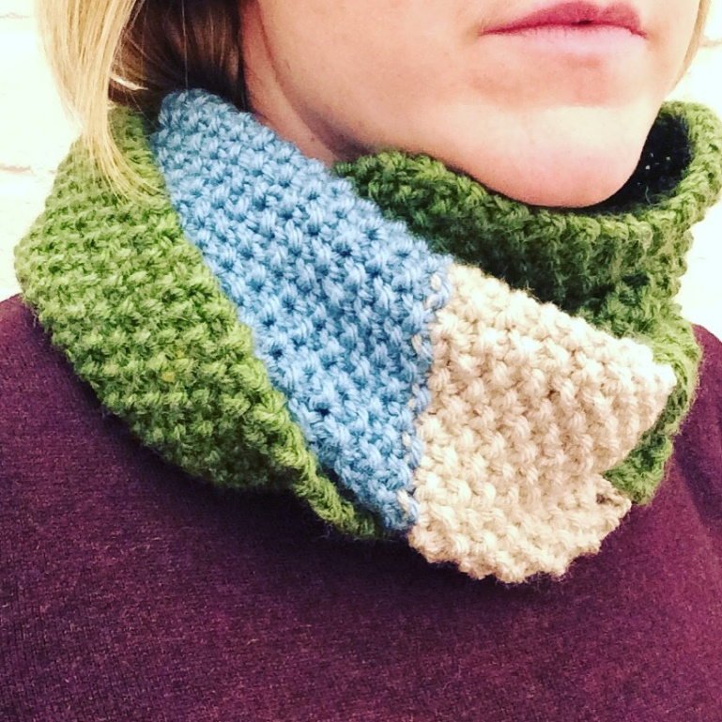

Grousemoor Chunky CY1027

Moss Infinity Scarf
Measurements
Size: approx. 125cm (49 inches) in length

Yarn
1 x 100g Grousemoor Chunky Moss 5937
1 x 100g Grousemoor Chunky Sky 6789
1 x 100g Grousemoor Chunky Fawn 871

Needles |  | Tension (not essential)
1 pair of 6mm needles  1 sewing needle |  | 12 stitches and 18 rows over 10cmx10cm

IT IS ESSENTIAL TO WORK TO THE STATED TENSION TO ENSURE THE CORRECT SIZING. If you tension square has less stitches, use a thinner needle, if more, use a thicker needle.

Pattern
Cast on 21 sts in Moss 5967, work in Moss Stitch (K1, P1)
(Casting on an uneven number of stitches makes this pattern symmetrical, either side can be the right side)
Continue in Moss Stitch for approx. 105cm (41 inches) and change to Sky 6789.
Continue in Moss Stitch for a further 12cm (4 ½ inches) and change to Fawn 871
Continue in Moss Stitch until work measures approx.. 125cm (49 inches).
Cast off in pattern. Sew the two ends together and wear with style!

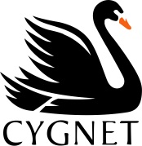
Cygnet Yarns Limited
12-14 Adelaide Street, Bradford, West Yorkshire, BD5 0EA
CY1010© 2015 Designed and published by Cygnet Yarns Limited of 12-14 Adelaide Street, Bradford, BD5 0EA.
This pattern is protected by the law of Copyright of the United Kingdom and may not be reproduced or copied. This pattern may be used for manufacturing purposes up to a limit of 20 garments. For anything more than this, please contact Cygnet Yarns. All other rights are expressly reserved by Cygnet Yarns Ltd.

